
Appointed Party Responsibilities
Guidance for Bailey Partnership (Group) Ltd Information Management: under BS EN ISO 19650-2:2018
Bailey Partnership (Group) Ltd operates a BIM Wiki page on the Bailey Partnership intranet. 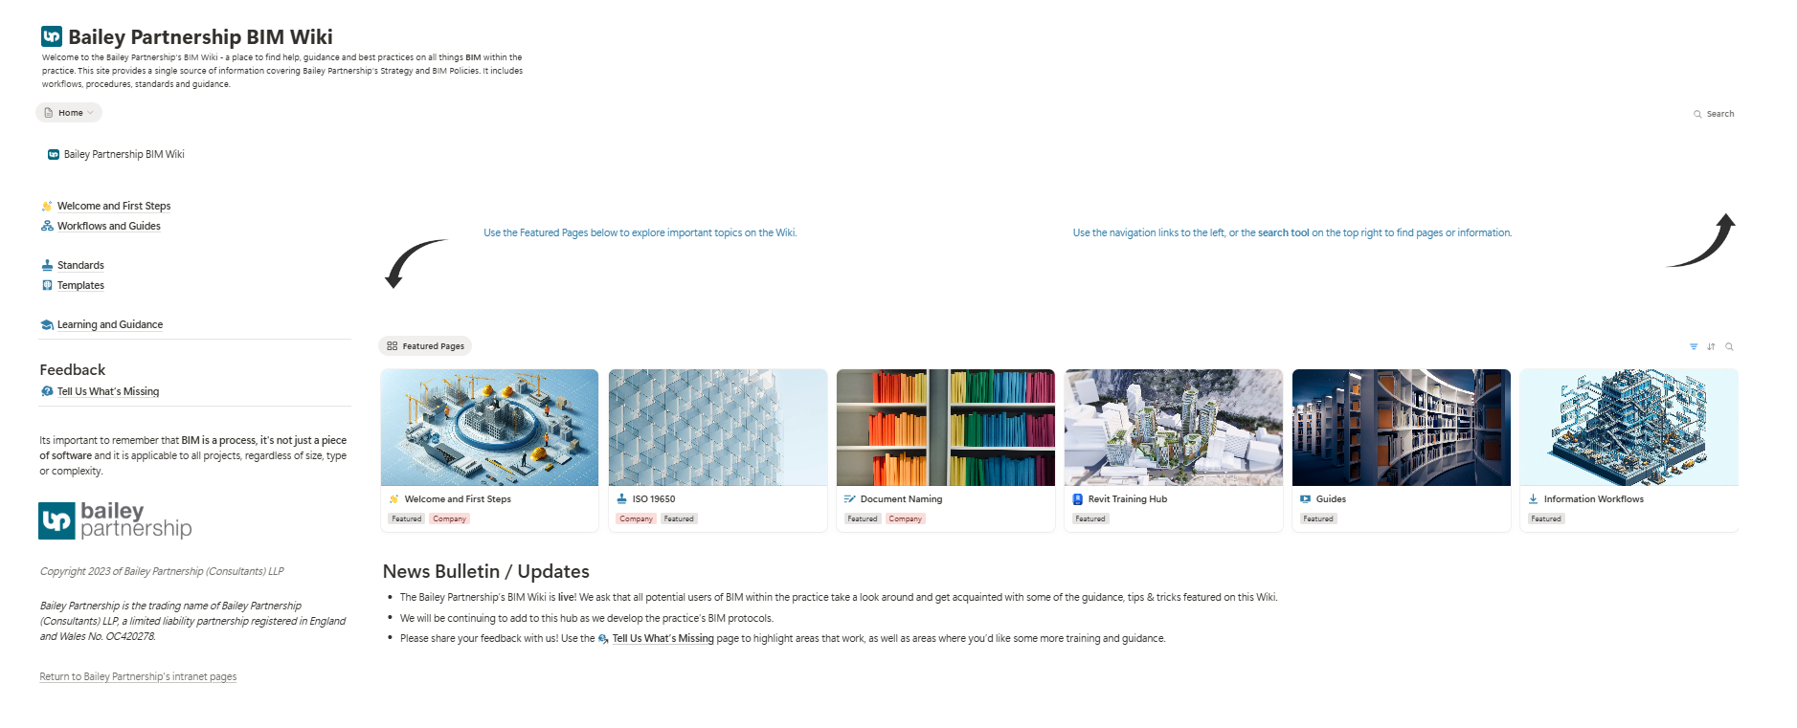 We also hold a BIM Induction for all new members of staff to ensure they understand the company information management system, training in the company CDE (ACC) and the principles of BS EN ISO 19650 Parts 1-6 and have access to the most recent version of any standards required.
1. Understanding the Role as an Appointed Party / Task Team
• Core Purpose: The primary role is to produce information collaboratively and efficiently, adhering to the appointing party's requirements and contributing to the overall project information model.
• Relationship within the Project Team: An Appointed Party are part of a delivery team and a project team. You will typically report to a Lead Appointed Party regarding information management, who in turn reports to the Appointing Party. The standard identifies and assigns the accountable party for each sub-activity.
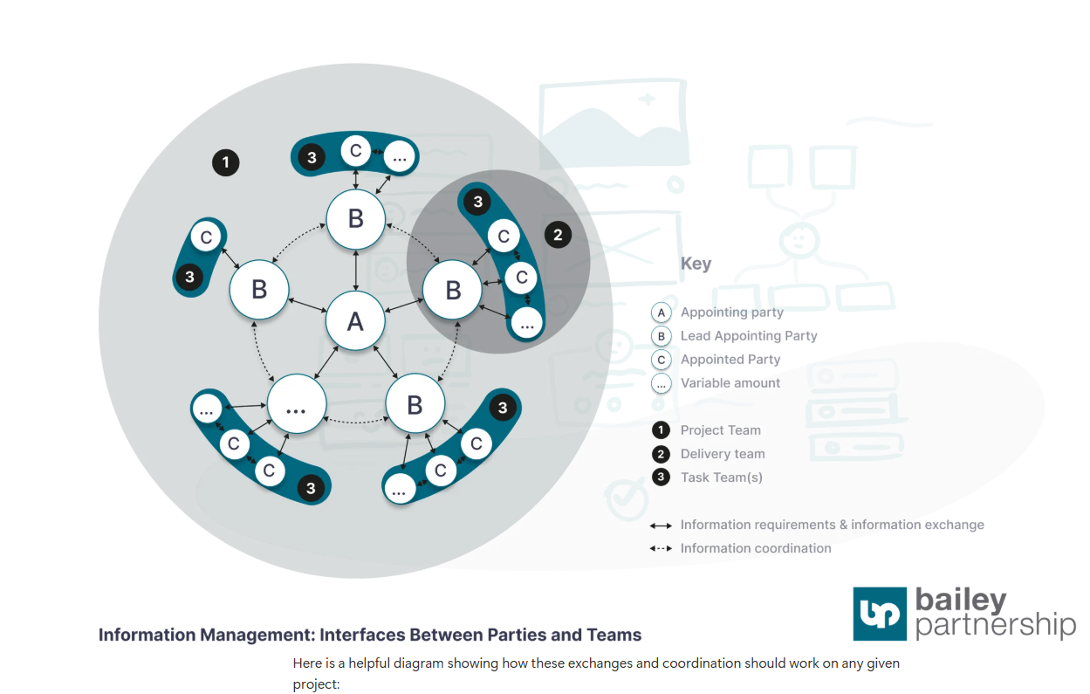
• UK Context: As the UK implementation of EN ISO 19650-2:2018, this standard, along with BS EN ISO 19650-1:2018, supersedes previous UK standards like BS 1192:2007+A2:2016 and replaces technical content from PAS 1192-2:2013. Ensure you are working with the latest guidance.
2. General Principles for Information Management
• Proportionality: Always apply the requirements of this document in a way that is proportionate and appropriate to the scale and complexity of the asset or project.
• Common Data Environment (CDE): All information exchange will happen through the project's CDE, in addition all information is also contained in the Bailey Partnership CDE (ACC) which must enable unique IDs for information containers, assigned attributes (status, revision, classification), transition between states, and controlled access.
• Information Standards and Procedures: We comply with the project’s information standard and information production methods and procedures established by the appointing party, including any agreed additions or amendments.
• Information Protocol: Adhere to the project's information protocol, which outlines obligations, warranties, liabilities, and intellectual property rights related to information.

3. Responsibilities by Information Management Process Phase
The information management process applies throughout the delivery phase for each appointment.
3.1. Tender Response Phase (Clause 5.3)
• Assess Task Team Capability and Capacity: Before appointment, Bailey Partnership (Group) Ltd (as a task team) shall undertake an assessment of its capability and capacity to deliver information in accordance with the appointing party’s exchange information requirements and the delivery team’s proposed BIM execution plan. This includes considering:
◦ Relevant experience and number of team members in managing and producing information.
◦ Relevant education and training available to team members.
◦ Availability of information technology (IT), including proposed IT schedule, hardware, IT infrastructure, and support.
• Contribute to the Delivery Team's (pre-appointment) BIM Execution Plan (BEP): Work with the prospective Lead Appointed Party to establish the delivery team’s proposed approach to information management, your task team's composition, and your capability and capacity to manage information.
• Contribute to Mobilisation Plan: Provide input to the Lead Appointed Party regarding the proposed mobilization plan, covering aspects like testing, IT, resources, and training.
• Contribute to Risk Register: Identify and communicate risks associated with the timely delivery of information within your scope to the prospective Lead Appointed Party.
3.2. Appointment Phase (Clause 5.4)
• Confirm the Delivery Team's BIM Execution Plan (BEP): As part of the delivery team, you will agree and confirm the BEP with the Lead Appointed Party. This includes confirming individuals undertaking information management, updating your information delivery strategy, and agreeing on information production methods and procedures, software, hardware, and IT infrastructure.
• Establish Detailed Responsibility Matrix: Understand your specific responsibilities within the detailed responsibility matrix, which identifies what information is to be produced, when it is to be exchanged, and which task team (you) is responsible.

• Establish Your Task Information Delivery Plan (TIDP): Bailey Partnership (Group) Ltd (as a task team) shall establish, and maintain throughout its appointment, a TIDP. This critical document should list and identify for each information container:
◦ Name and title.
◦ Predecessors or dependencies.
◦ Level of information need.
◦ (Estimated) production duration.
◦ The information author responsible for its production.
◦ Delivery milestones.
◦ Consider: Project’s information delivery milestones, your responsibilities in the detailed responsibility matrix, Lead Appointed Party’s information requirements, shared resources, and time needed for production.
• Review Appointment Documents: Ensure you fully understand the appointment documents from the Lead Appointed Party, which will include their exchange information requirements, the project’s information standard, protocol, the delivery team’s BEP, and your agreed TIDP.
3.3. Mobilisation Phase (Clause 5.5)
• Mobilise Resources and IT: Implement your part of the delivery team's mobilization plan, ensuring your resources (personnel, knowledge, skills) and information technology (software, hardware, CDE configuration) are ready.
• Test Information Production Methods and Procedures: Participate in testing the project’s information production methods and procedures, refining and verifying breakdown structures, and developing shared resources for your team.
3.4. Collaborative Production of Information Phase (Clause 5.6)
This is your core activity as an Appointed Party/task team.
• Check Availability of Reference Information and Shared Resources: Before generating information, check you have access to relevant reference information and shared resources in the CDE. Notify the Lead Appointed Party immediately if there are any issues affecting your TIDP.

• Generate Information: Generate information in accordance with your TIDP, ensuring it:
◦ Complies with the project’s information standard.
◦ Adheres to the project’s information production methods and procedures.
◦ Does not exceed the required level of information need.
◦ Does not extend beyond your allocated element of the information container breakdown structure.
◦ Does not duplicate information generated by other task teams or contain superfluous detail.
◦ Is coordinated and cross-referenced with information in the CDE, including spatial coordination of geometrical models. Resolve coordination issues collaboratively, escalating to the Lead Appointed Party if needed.
• Undertake Quality Assurance (QA) Check: Undertake a QA check of each information container according to the project’s information production methods and procedures and the project’s information standard. Mark as checked and record the outcome if successful; reject and inform the author if unsuccessful.
• Review Information and Approve for Sharing: Review information within the container before sharing in the CDE, considering the Lead Appointed Party’s information requirements, level of information need, and information for coordination by other task teams.
◦ If successful, assign the appropriate suitability status and approve for sharing.
◦ If unsuccessful, record the reasons, required amendments, and reject the container.
• Participate in Information Model Review: Contribute to the delivery team’s review of the information model to ensure continuous coordination across all elements.
3.5. Information Model Delivery Phase (Clause 5.7)
• Submit Information for Lead Appointed Party Authorization: Submit your information to the Lead Appointed Party for authorization within the project’s CDE, prior to delivery to the Appointing Party.
• Submit Information for Appointing Party Acceptance: Once authorised by the Lead Appointed Party, submit your information for Appointing Party review and acceptance within the project’s CDE.

3.6. Project Close-out Phase (Clause 5.8)
• Capture Lessons Learned: Collaborate with the Lead Appointed Party to capture lessons learned during the project for future reference.
4. Key UK-Specific Information Management Requirements (National Annex NA)
The National Foreword highlights the National Annex NA for clarifications and recommendations specific to UK users.
• Information Container Identification (ID):
Bailey Partnership (Group) Ltd have created a Document Naming Tool for all staff so that all documents created by the company may create document names based on the BSEN ISO 19650-2 (2018) codes. The exception to the rule is compliance with the naming conventions strictly specified by the Lead Appointed/Appointing Parties.
◦ Our project file information containers in CDE should use a unique ID structured with all the fields in the specified order: Project-Originator-Functional Breakdown-Spatial Breakdown-Form-Discipline-Number.
• Information Container Metadata and Status Description :
◦ Status (Suitability): Apply status codes according to Table NA.2. This includes:
▪ S0 for "Work in Progress" (WIP).
▪ S1-S5 for "Shared (non-contractual)" information containers (e.g., S1 for coordination, S2 for information/reference, S3 for review/comment, S4 for Lead Appointed Party authorisation, S5 for Appointing Party acceptance).
▪ A1, An for "Published (contractual)" information containers. The reasons for issue associated with different 'An' codes should be defined in the project's information standard.
◦ Revision: Use Pxx (e.g., P01) for preliminary revisions, with a two-integer suffix for WIP versions (e.g., P02.05) to track changes within a task team. The initial revision is P01.01. Use Cxx (e.g., C01) for contractual revisions.
◦ Classification: Classify information containers according to Uniclass 2015, using the PM table where possible.
• Information Model Exchange:
◦ Information models exchanged with the appointing party should typically include geometrical information, alphanumerical information, and documentation.
◦ Recommended Open Data Formats:
▪ Geometrical Information: Proprietary formats or ISO 16739-1 (IFC) schema files.
▪ Alphanumerical Information: Open data formats like BS 1192-4:2014 (COBie) or ISO 16739-1 (IFC).
▪ Documentation: Open data formats such as ISO 32000-1/2 (PDF).
◦ Classification within Information Containers: Ensure classification within information containers is in accordance with Uniclass 2015 tables.
• Project’s Information Requirements: When establishing the project’s information requirements, the Appointing Party will define information delivery milestones in relation to key decision points within principal work stages as set out in BS 8536-1:2015 (for buildings) or BS 8563-2:2016 (for linear/geographical infrastructure). Be aware of which standard is being used and how your deliveries align.

Additional UK Guidance
• UK BIM Framework Guidance Suite: Utilise the UK BIM Framework guidance suite, particularly "Information management according to BS EN ISO 19650 – Guidance Part 2: Parties, teams and processes for the delivery phase of the assets," which provides support for the National Annex.
By adhering to these points, Bailey Partnership (Group) Ltd can effectively navigate its responsibilities as an Appointed Party under BS EN ISO 19650-2:2018 in the UK, contributing to successful information management throughout the asset delivery phase.

